**Question 1:** A square prism, side of base 40 mm and axis 60 mm long, rests with its base on HP such that one of its rectangular faces is inclined at 30° to VP. A section plane perpendicular to HP and inclined at 60° to VP passes through the prism such that a rectangular face which is making 60° with VP is cut into two halves. Draw the top view, sectional front view and true shape of section.

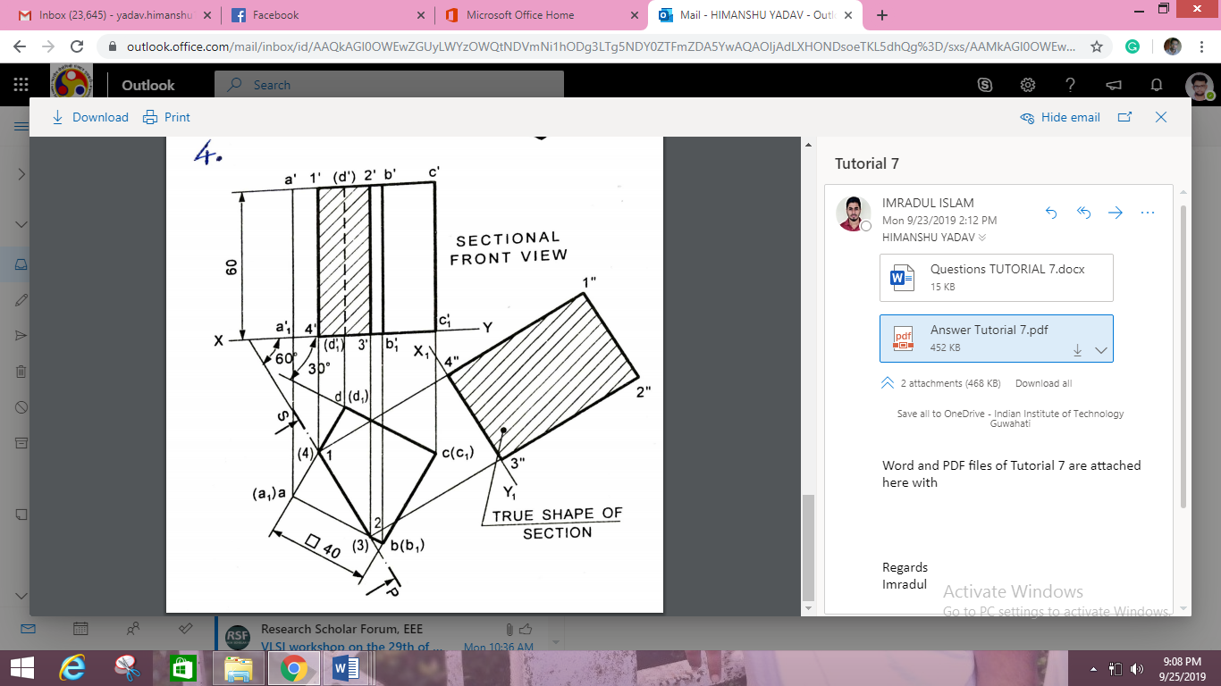

**Question 2:** A cone base 65 mm diameter and axis 70 mm long is resting on its base on H.P. It is cut by a section plane perpendicular to the V.P., inclined at 45° to the H.P. and cutting the axis at a point 30 mm from the apex. Draw the front view, sectional top view, sectional side view and true shape of the section.

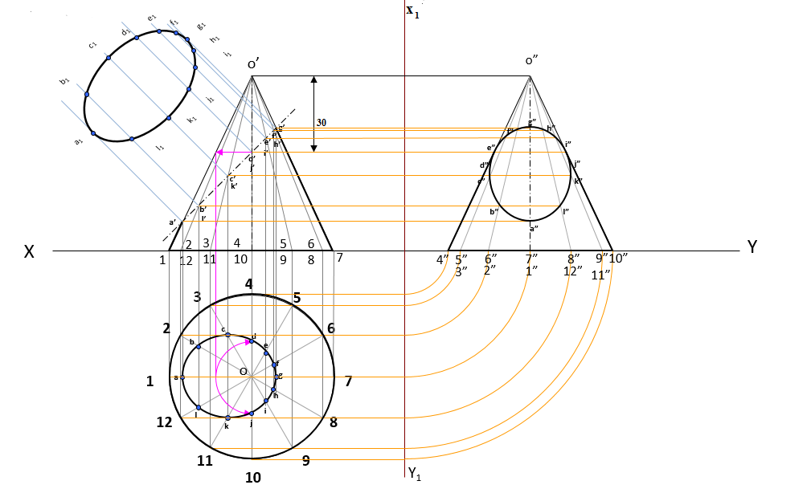

**Question 3:** A square pyramid of base 50mm side and axis 70 mm long has its base on the HP and all the edges of the base equally inclined to the VP. It is cut by a section plane perpendicular to the VP, inclined at 45° to the HP and bisecting the axis. Draw the sectional tip view, sectional side view and the true shape of the section

